Project Development Phase
Performance Test

Date | 10 February 2026
Team ID | LTVIP2026TMIDS25024
Project Name | Visualizing Housing Market Trends: An Analysis of Sale Prices and Features using Tableau
Maximum Marks

Model Performance Testing:
Project team shall fill the following information in model performance testing template.
S.No. | Parameter | Screenshot / Values
1 | Data Rendered | The dataset Transformed_Housing_Data2.csv was successfully loaded and rendered in Tableau Desktop. All records were displayed correctly without any errors. Tableau automatically classified the dataset into dimensions and measures, enabling accurate visualization and analysis.  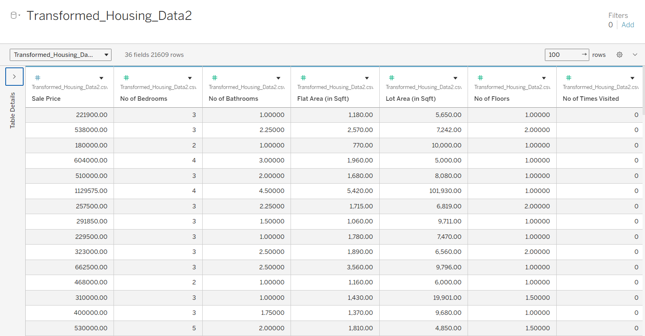
2 | Data Preprocessing | Data preprocessing steps included verifying data types, cleaning dataset, and validating records. Numerical fields such as Sale Price and Basement Area were correctly identified as measures, while categorical fields such as Renovation Status, Bedrooms, Bathrooms, and Floors were identified as dimensions. No major missing or invalid data was found.  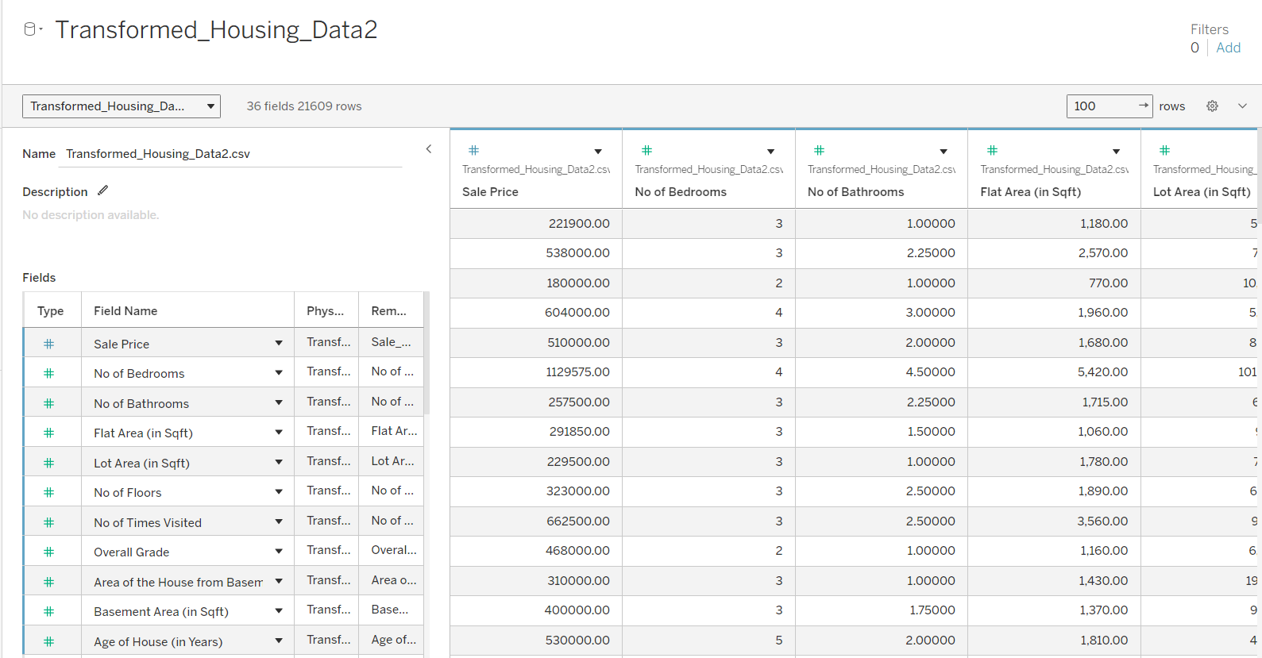
3 | Utilization of Filters | Interactive filters were applied to enhance dashboard usability and analysis. Filters such as Sale Price, House Age, and Renovation Status were used to allow users to dynamically explore housing data and view filtered visualizations. The filters responded efficiently without performance issues.
4 | Calculation Fields Used | Tableau calculation features were used to generate aggregated metrics such as COUNT(Number of Records), AVG(Sale Price), and SUM(Basement Area). These calculated values were used in KPI indicators and charts to provide meaningful insights.
5 | Dashboard Design | No of Visualizations / Graphs: 6
Visualizations included:
• Total Houses (KPI)
• Average Sale Price (KPI)
• Total Basement Area (KPI)
• Sales by Years Since Renovation (Bar Chart)
• House Age Distribution by Renovation Status (Pie Chart)
• Feature Distribution by Bedrooms, Bathrooms, and Floors (Bar Chart)
The dashboard was designed with proper layout, labels, and interactive elements.
 |  | 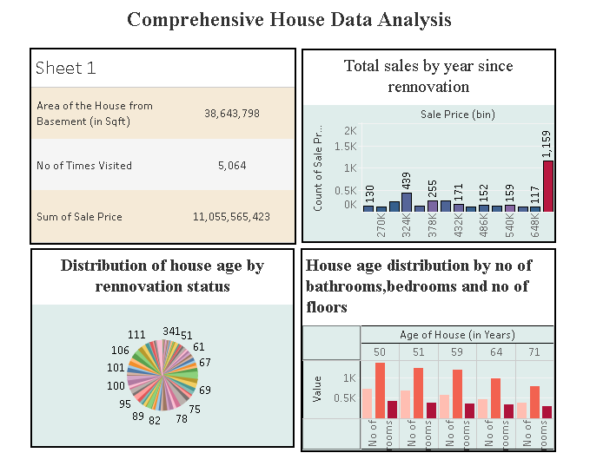
6 | Story Design | No of Visualizations / Graphs: 4
Story included the following scenes:
• Dataset Overview
• Renovation Impact Analysis
• House Age Distribution Analysis
• Feature-Based Analysis
The story was structured logically to explain housing market insights step-by-step.
 |  | 